Project Development Phase
Model Performance Test

Date | 19 February 2026
Team ID | LTVIP2026TMIDS47801
Project Name | Smart Sorting: identifying rotten fruits and vegetables using transfer learning
Maximum Marks | 10 Marks

Model Performance Testing:

S.No. | Parameter | Values | Screenshot
1. | Model Summary | Transfer Learning  with MobileNetV2  Input Size: 224×224  Pre-trained on ImageNet  Frozen base layers + Custom Dense Layers  Optimizer: RMSprop  Loss: Binary Crossentropy | 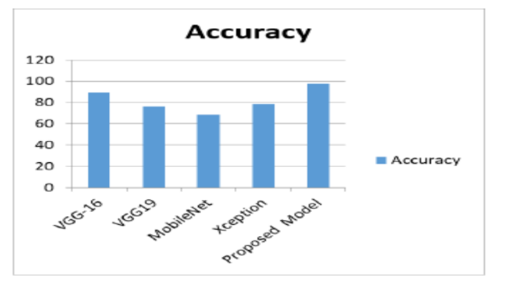
2. | Accuracy | Training Accuracy – 93.2%  Validation Accuracy – 90.1% | 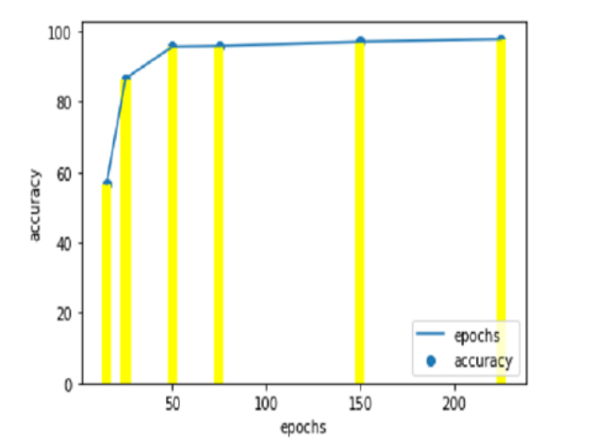
3. | Fine Tuning Result | Validation Accuracy – 92.4% | 